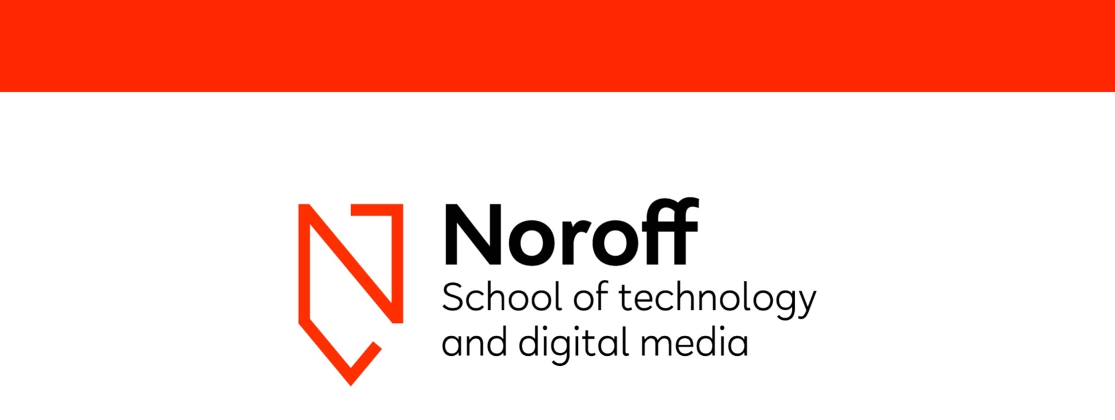Technical Report

**Research**

**Frode Karlsen**

**Word count**

Summary: 35 | Main text: 1013



Table of Contents

1. Summary …….……………………………………….3

2. Body

i. Target audience research ….…………......4

ii. Product research ……...……………………5

iii. Personas ………………………………….6-7

iv. Scenarios …………...……………………...8

v. Storyboard …………..…………………..9-10

vi. Wireframe and prototype..……………11-15

3. References ………………………………………...16

1. Summary

This report contains target audience research, product research, personas, scenarios, storyboard, wireframe sketching and a link to the prototype of Hubspot. Here you will see my though process while performing researching of my project exam.

2. Body

i. Target Audience Research

To kick this off, I need to know who the main target audience for NASA is, but to answer that question we need to look at what NASA does. NASA is more than just astronauts. They provides careers in tons of fields such as science, engineering, IT, human resources, accounting, writing, technicians and so forth.

NASA as a company is all about exploring the extraordinary, and this is what entices their target audience. It’s something exciting, it’s the dream many had as a kid becoming an astronaut, it’s about being on team earth of exploring the universe we live in. It’s about team work in order to break barriers to achieve something seemingly impossible. They are basically dreamers that wants to explore the unknown.

So, what are we looking at here? As per their workforce, NASA consists of 72% white or Caucasians.

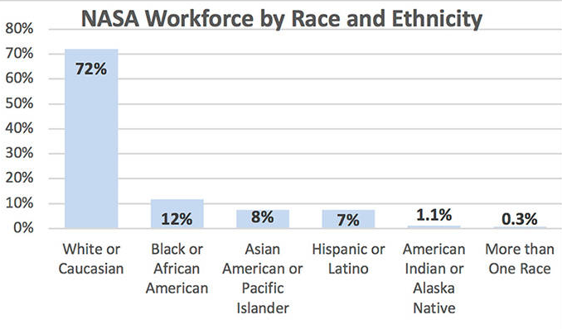

Most of NASA’s jobs are technical related and demand higher education, leaning towards a very high percentage of men. According to Google’s workforce, tech related jobs are at 83% male in terms of gender diversity, which is very high. In other words we predominately looking at men that are interested in science/tech. The age range of the target audience will be anything from kids to adults that share these interests.

ii. Product Research

The journey started around 400 years ago, when Galileo turned his telescope towards the skies in 1610. We quickly learned that Saturn had wings, Jupiter had moons, the Milky Way was not a cloud but a collection of countless stars. Within a few years, our understanding of ‘our world’ would be changed forever.

In the centuries that followed, telescopes grew in size and complexity, and of course, power. In comes Edwin Hubble in 1920, from whom the Hubble Telescope is named after. He used the largest telescope available during his day in the 1920s at the Mt. Wilson Observatory to discover galaxies beyond our own.

Hubble, the observatory, is the first major optical telescope to be placed in space, the ultimate mountaintop. Above the distortion of the atmosphere, far above rain clouds and light pollution, Hubble has an unobstructive view of the universe. Scientists have used Hubble to observe the most distant stars and galaxies as well as the plants in our solar system.

Hubble’s launch and deployment in April 1990 marked the most significant advance in astronomy since Galileo’s telescope. Thanks to five servicing missions and more than 25 years of operation, our view of the universe and our place within it has never been the same..

So, we are looking at a great history of exploration, dreaming, aspirations, science and technical advancements. That is exactly what drives our target audience. In the end space exploration is all about people, the human race and its journey through investigating our own existence and the world around us.

iii. Personas

I need my personas to be male Caucasians that are basically a bit ‘geeky’. I went for Leonard and Howard from The Big Bang Theory, which fits my target group perfectly. They should be both relatable and in the target audience of the microsite:

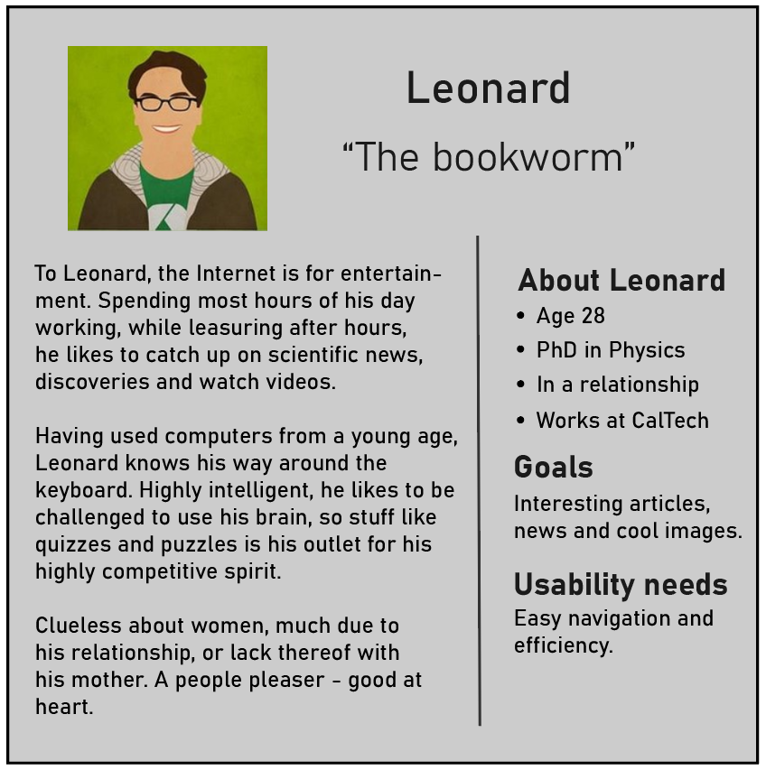

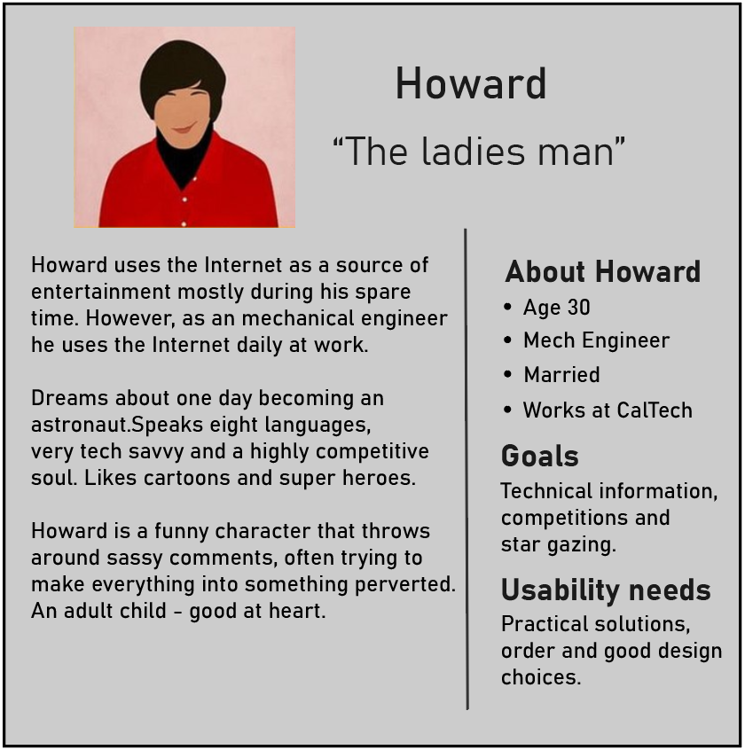

iv. Scenarios

The scenarios I have made are basically done to better understand our target audience, and when and how they would visit our site most likely. These are just simple sketches of scenarios I have made:

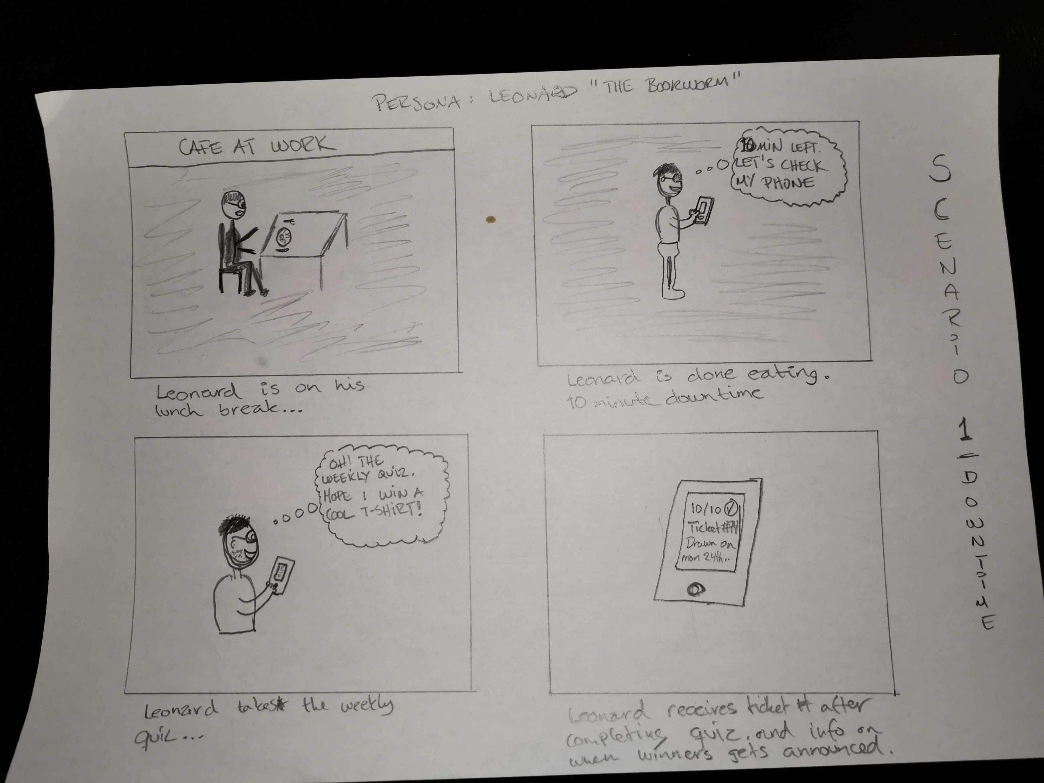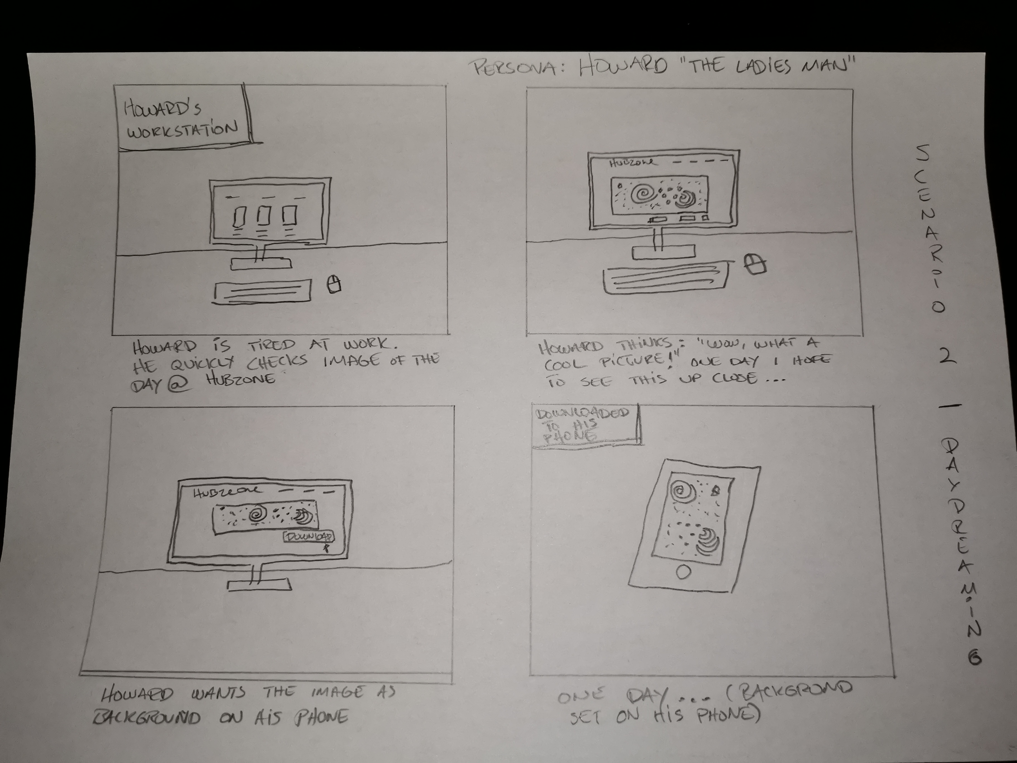

v. Storyboard

My storyboard is just a simple mockup of how I want the page structure to look like:

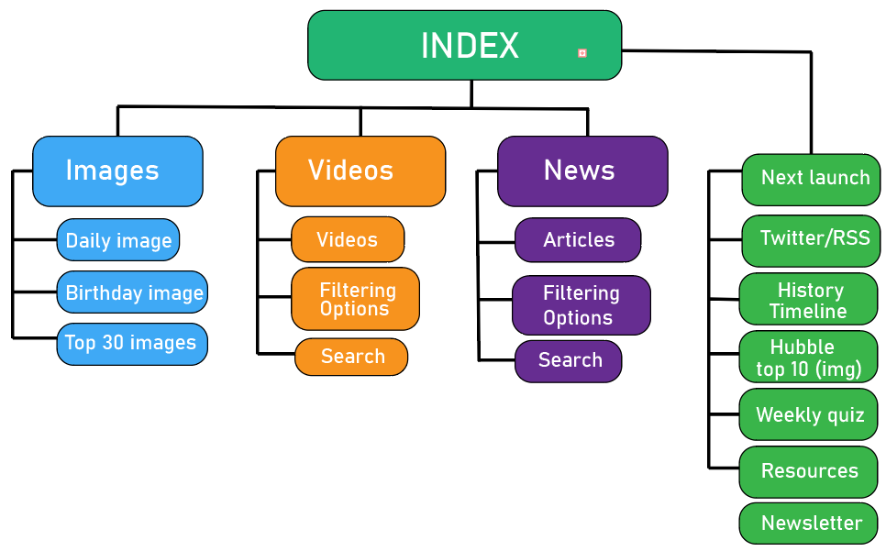

The index page will have a counter for next launch, a twitter RSS feed with tweets and news about the Hubble Telescope, a history timeline for those interested reading about the history, top 10 images, the weekly quiz, resources and a newsletter signup. The ‘Next launch’ section will link to another page consisting of launch details, which I plan to implement via usage of API callout.

The navigation section on the landing page will have ‘Home’ for index page, images, videos and news.

The ‘images’ page will contain a daily image highlighted up top with a short description below. The birthday image section is a direct link to NASA’s website, where users can input their date of birth and get an image taken on that day by a telescope. The top 30 images section is self explanatory. I might add a sorting option here as well.

Moving on to the ‘videos’ page. This will be a really simple layout page with video links that people can watch. Filtering and search possible. Will implement API if possible.

The ‘news’ page will also be very simple. News articles by default most recent last. Sorting and search options will be available, along with next and previous page. This might also be added to the image page.

vi. Wireframe and Prototype

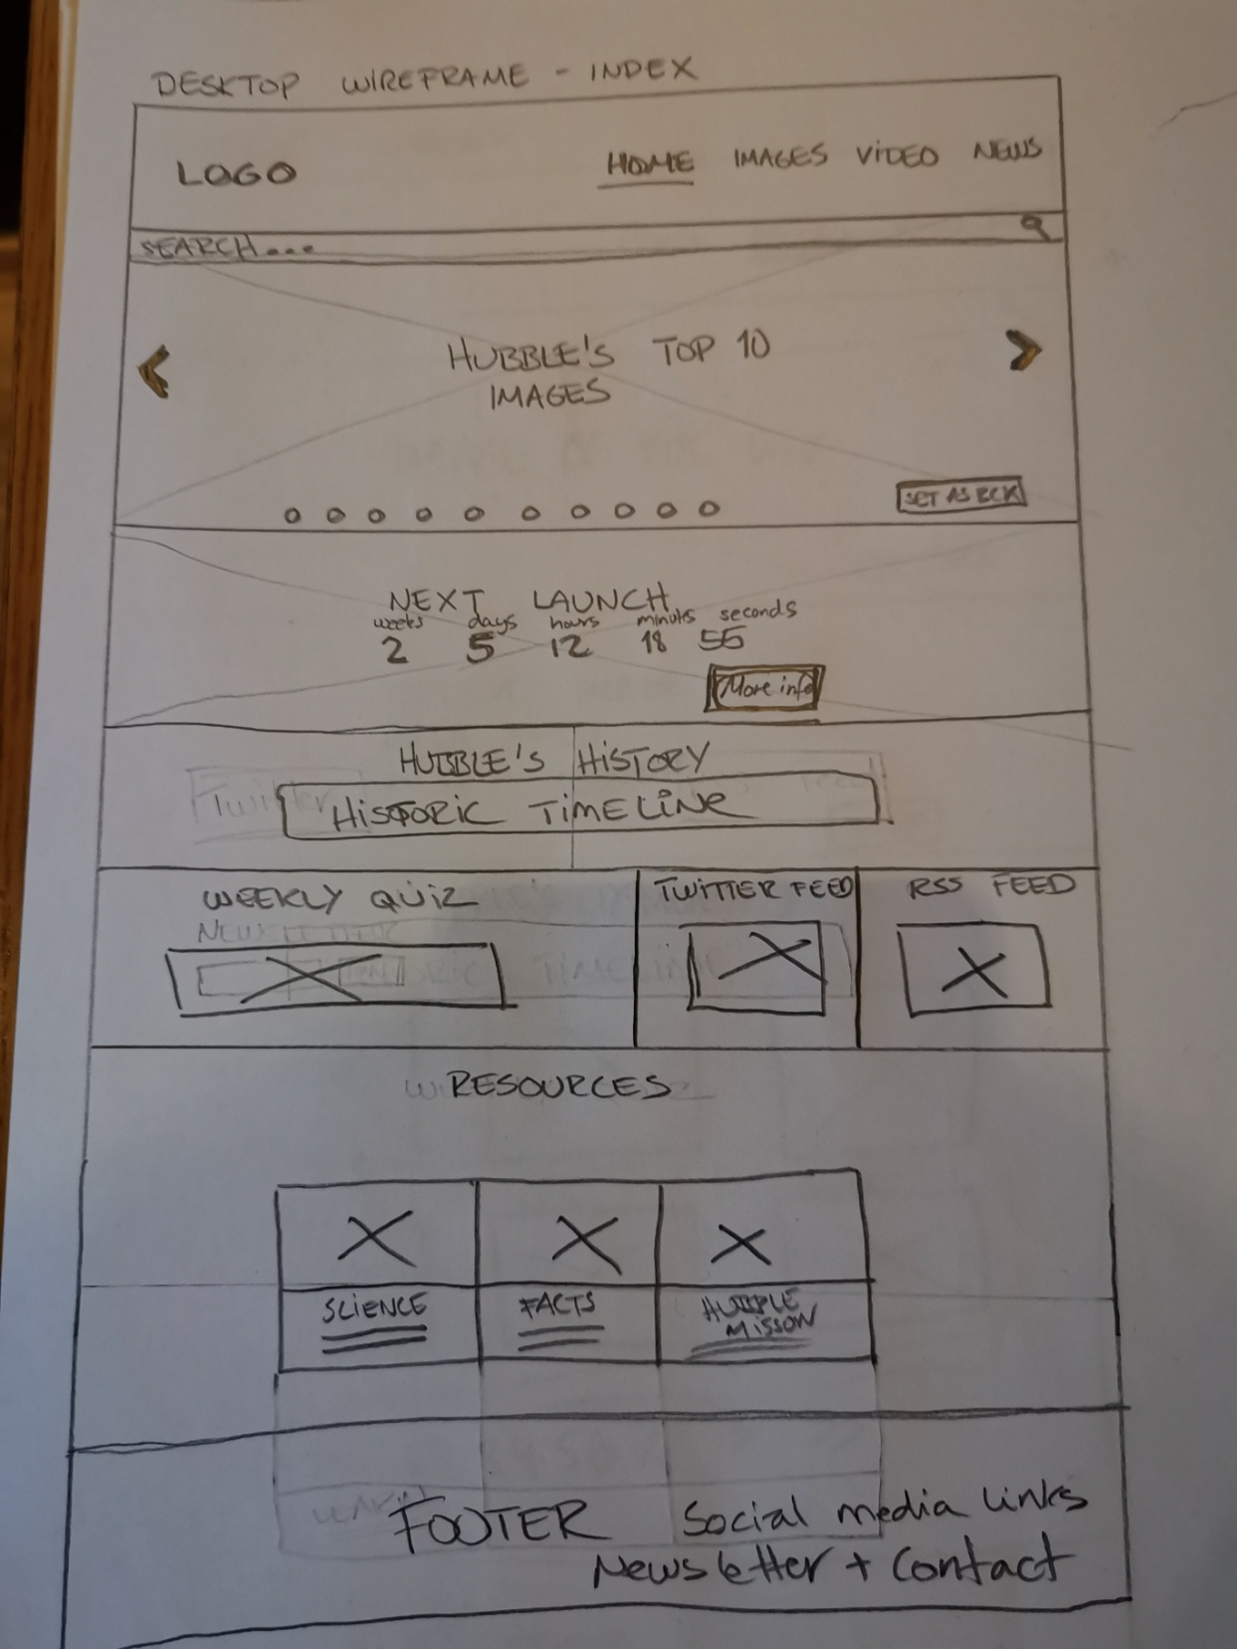

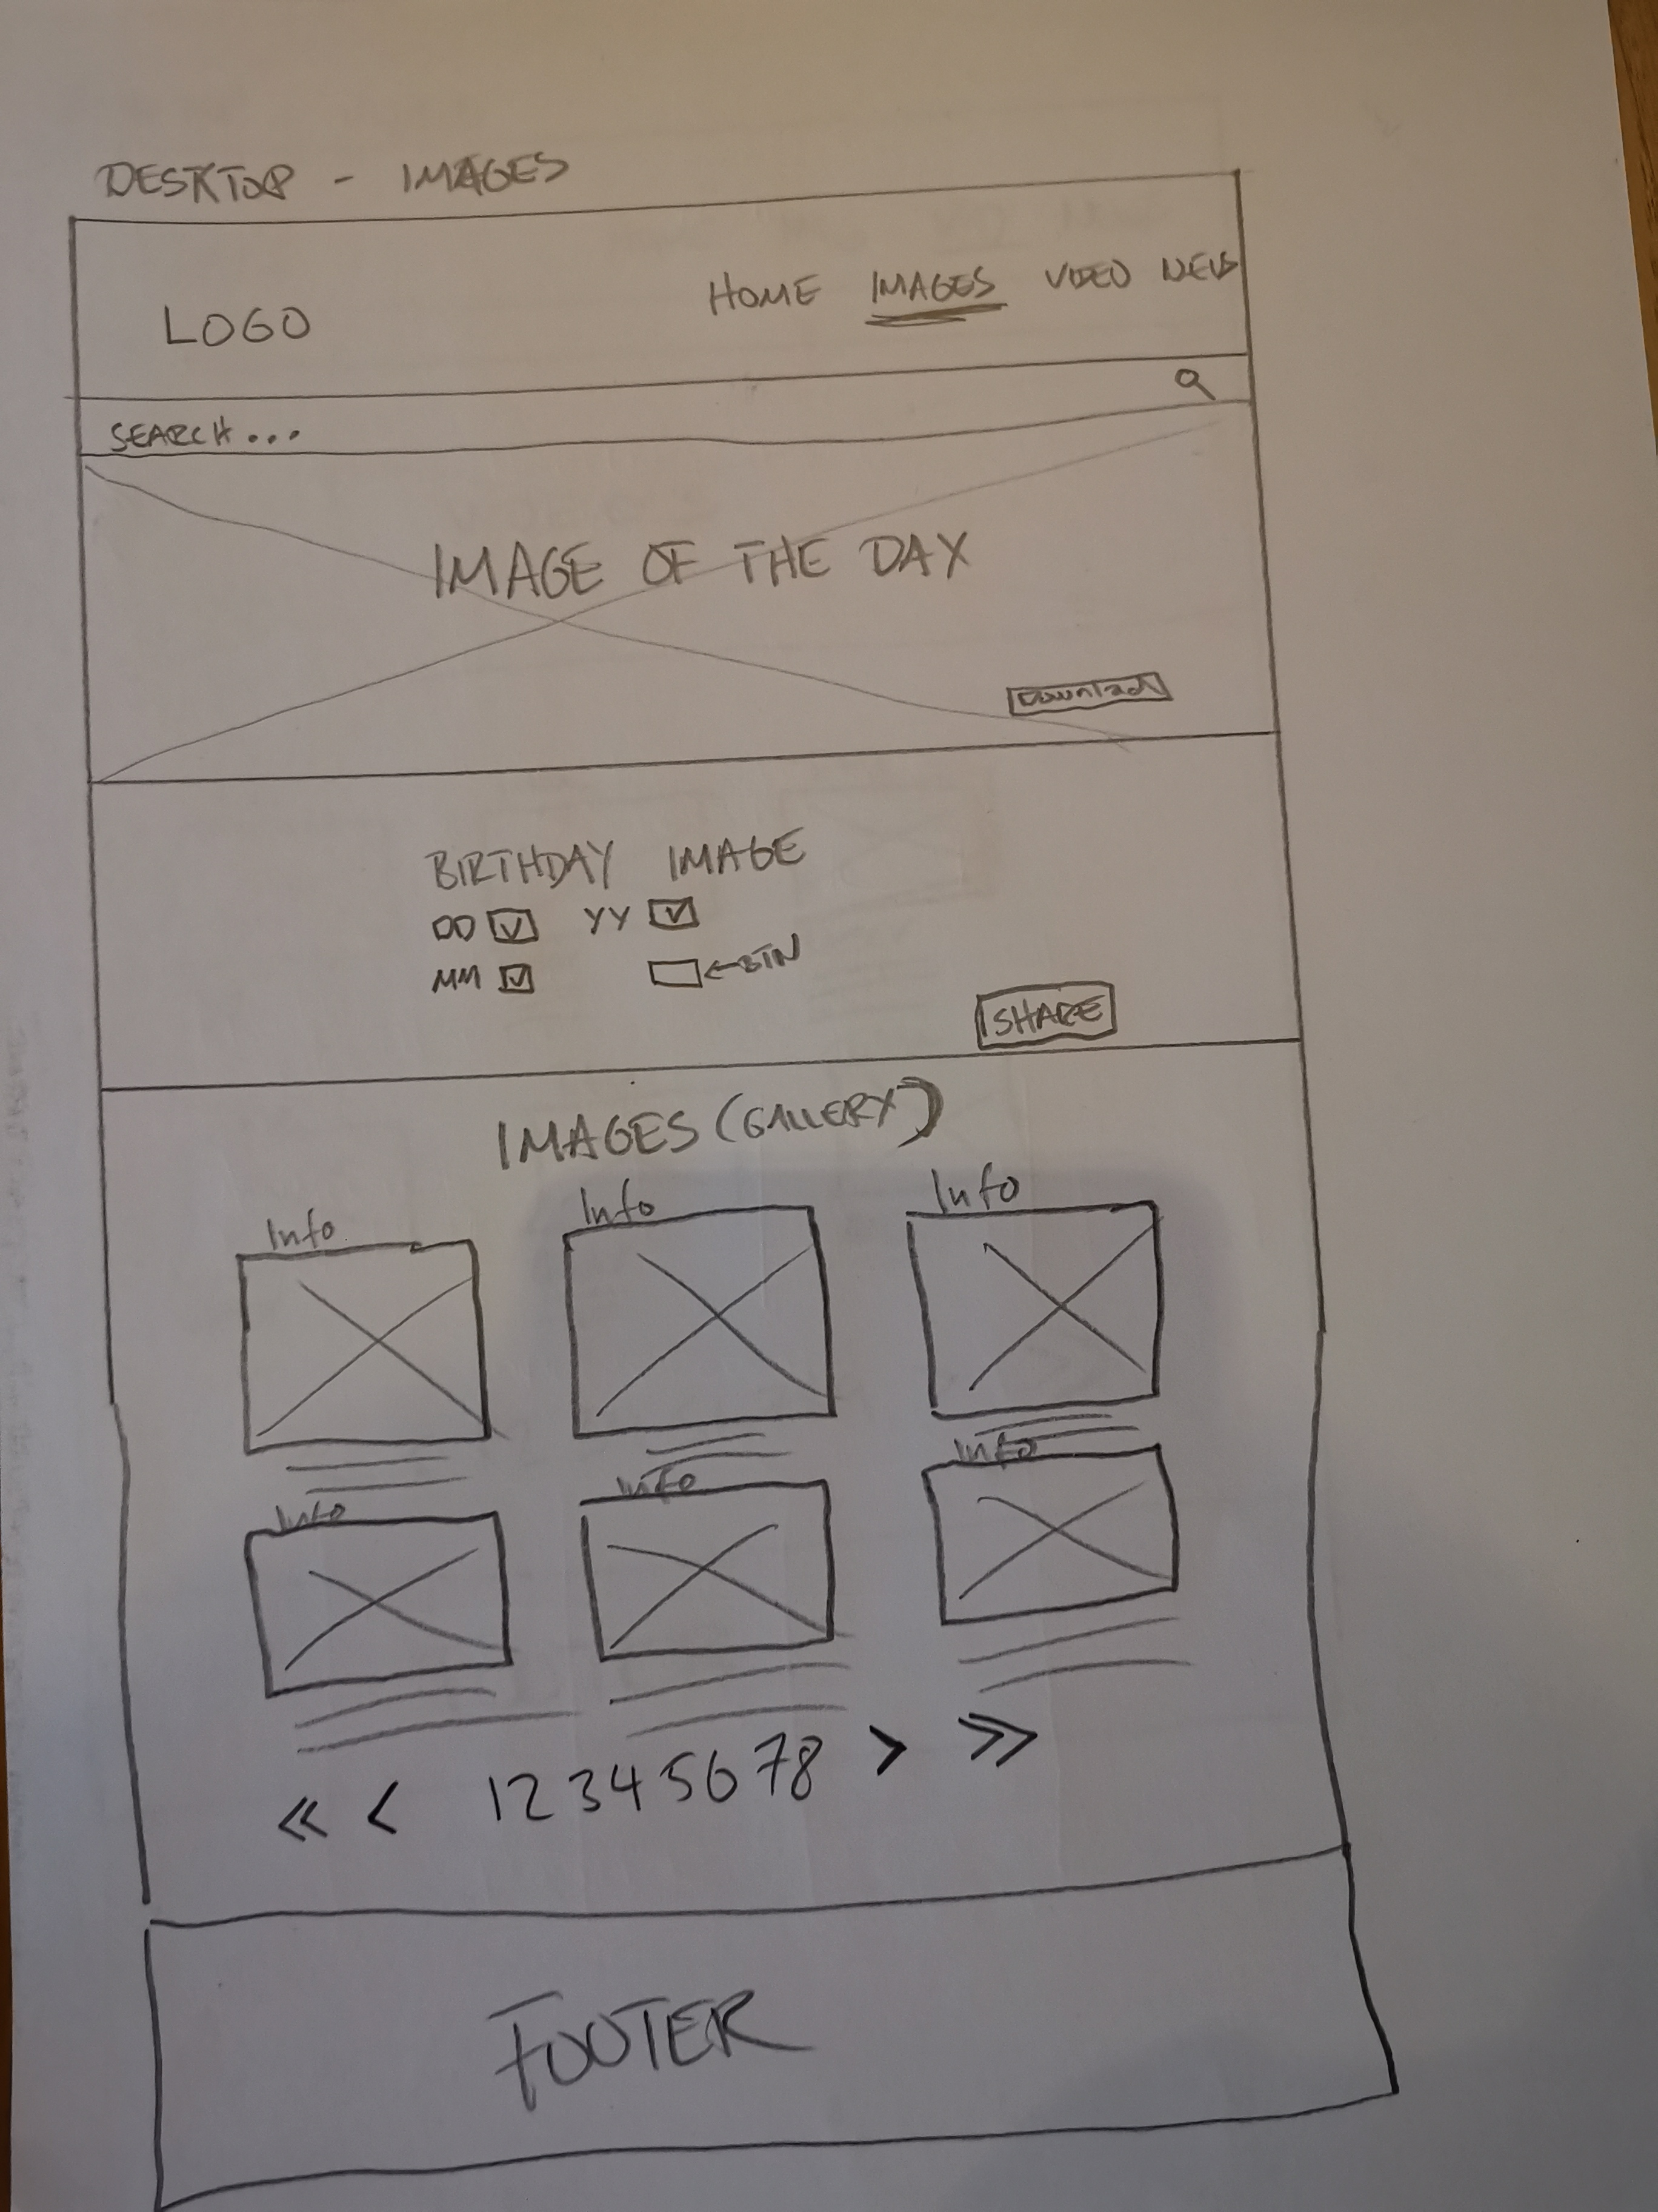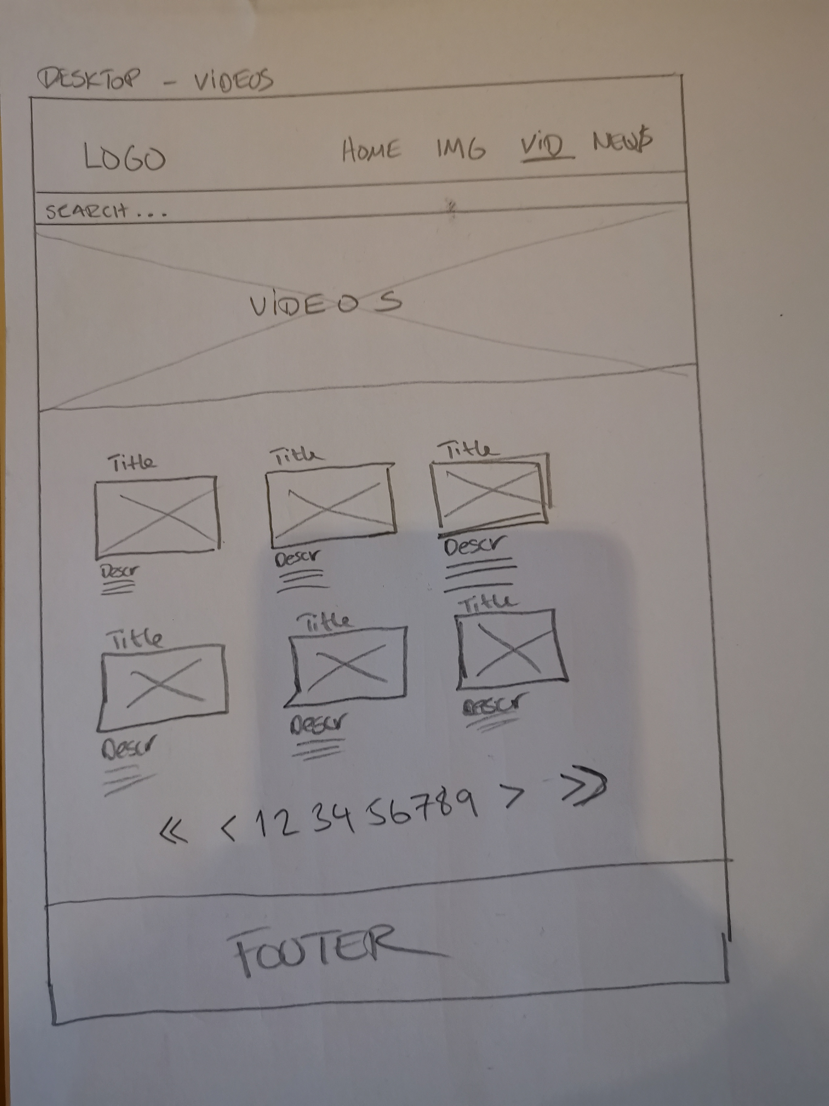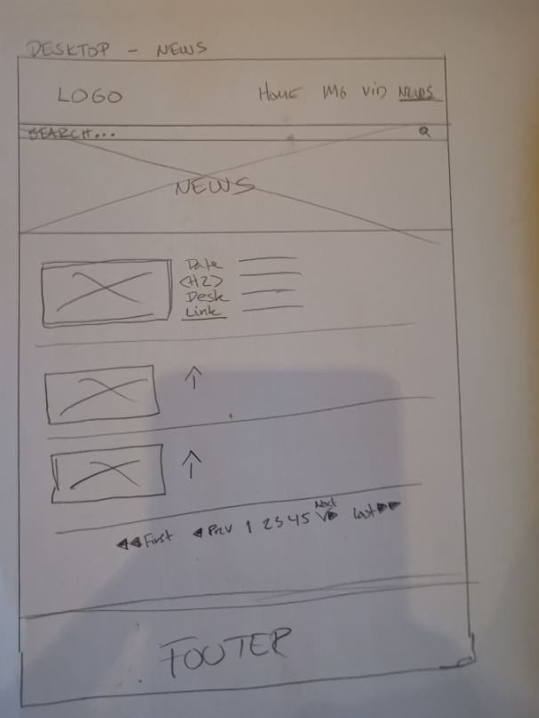

The process started off by making paper sketches of wireframes for desktop. The mobile version will be a 1-column layout, so I skipped the sketches for that and focused on sketching for desktop, which will have a 3 column layout. As for the wireframe, I made pencil sketches for each of the 5 pages (home, images, video, news and contact), as you can see from the images.

Now that the sketching was done, I moved to Adobe Xd to create the prototype. I basically used the sketches as a base. On Monday to Wednesday next week I will work on design, so this is not necessarily the ‘finished look’, but it’s close to what I would like the site to look like. The main idea is that it’s a microsite, so it will mostly be focused on engagement with NASA’s community by promoting cool images, a cool looking design of the page, quizzes, videos and social media links. The main idea is in the name I have chosen for the website; Hubspot – a hangout spot for people interested in the Hubble Telescope, and a celebration of its 30th anniversary.

I see now that I have not gotten any parts of the page focusing on the 30th anniversary, but I will sort that out.

3. References

Link to Adobe Xd Prototype:   
https://xd.adobe.com/view/c1702948-9a5e-4ce6-7a59-167246322eea-b741/